`

Student Name | ANSWERS
Teacher | GSL | MDI | HAL | SMH

CHEMISTRY
Unit 4, SAC 1: Diversity of carbon compounds
Unit 4, SAC 2: Chemistry of Food
Test on concepts from Chapters 10-17.1 of Heinemann Chemistry 2
Monday 14th of September, Period 2
Reading time: 5 minutes
Writing time: 65 minutes

Structure of Report
Section | AOS | Number of questions | Number of questions to be answered | Number of marks
A (multiple choice) | 2 | 10 | 10 | 10
B (short answer) | 1 & 2 | 4 | 4 | 37
 |  |  |  | Total 47

- Students are permitted to bring into the assessment room: pens, pencils, highlighters, erasers, sharpeners, rulers and one scientific calculator.
- Students are not permitted to bring into the examination room: blank sheets of paper and/or white out liquid/tape.
Materials supplied
- This question and answer book of 12 pages.
- A data book
Instructions
- Write your name in the space provided above on this page.
- All responses must be written in English.
- Working out must be shown for all calculations
- Do NOT write on the data book
At the end of the assessment session
- Wait silently for the supervisor to collect your question and answer booklet and data book.
Students are NOT permitted to bring mobile phones and/or any other unauthorised electronic devices into the examination room.
Students must not disclose the contents of the task; to do so will be a breach of VCE guidelines and will be dealt with according to VCAA regulations.

SECTION A: Multiple-choice questions
Instructions for Section A
Answer all questions in pencil on the answer sheet provided for multiple choice questions.
Choose the response that is correct or that best answers the question.
A correct answer scores 1, an incorrect answer scores 0.
Marks will not be deducted for incorrect answers. No marks will be given if more than one answer is completed for any question.
Question 1
The structure of a polypeptide is represented below:
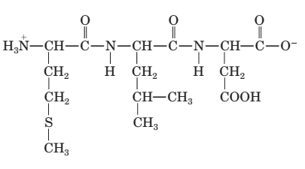
Which of the amino acids listed would not be produced when this molecule undergoes hydrolysis?
- isoleucine
- leucine
- methionine
- aspartic acid

Question 2
Palmitic acid, oleic acid, and linoleic acid are all fatty acids that can form triglycerides.
When comparing these acids it can be said that:
- oleic acid and linoleic acid are both polyunsaturated fatty acids.
- palmitic acid is the only fatty acid that will not react with Br₂ and has the highest melting point.
- the order of melting points (lowest to highest), is: linoleic acid, oleic acid, palmitic acid.
- linoleic acid is the most saturated fatty acid and has the lowest melting point.

Question 3
Under suitable conditions, 4.60 g of glycerol was reacted with excess linoleic acid to form a triglyceride of molar mass 878 g mol⁻¹.
Which of the following can be deduced about this reaction?
- The hydrolysis reactions will produce 2.70 g of water.
- The condensation reactions will produce 2.70 g of water.
- The hydrolysis reactions will produce 0.90 g of water.
- The condensation reactions will produce 0.90 g of water
n (glycerol) = m/M = 4.6 g /92 g mol⁻¹ = 0.05 mol
n (H₂O) = 3 x n(glycerol) = 3 x 0.05 mol = 0.15 mol
m (H₂O) = n x M = 0.15 mol x 18 g mol⁻¹ = 2.70 g

Refer to the following structures for Questions 4 and 5
The following structures show the amino acid alanine in different forms.
A. | 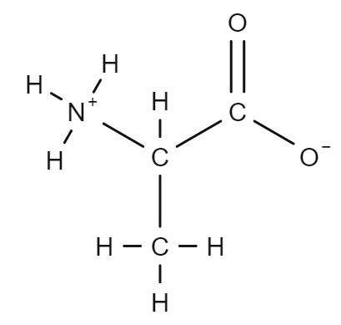 | C. | 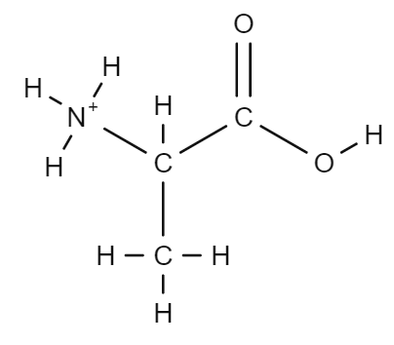
B. | 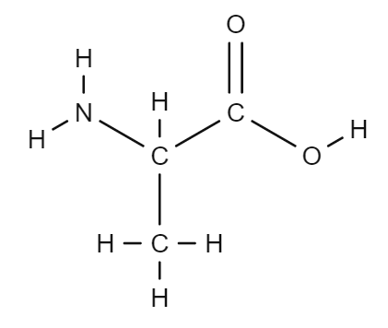 | D. | 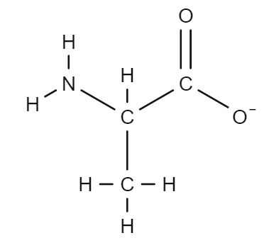
Question 4
Which of the structures represents alanine in its cationic form?
- Structure A
- Structure B
- Structure C
- Structure D

Question 5
Which of the structures would be most likely to form in a solution at a pH of 13?
- Structure A
- Structure B
- Structure C
- Structure D

Question 6
Lactase is an enzyme that is essential to the digestion of whole milk; it breaks down lactose, the main sugar component of milk. The optimum temperature for human lactase is about 37 ºC and the optimum pH is 6.
Based on this information, the reaction that is catalysed by lactase, and the location of lactase in the human body is most likely to be:
- condensation; in the small intestine
- condensation; in the stomach
- hydrolysis; in the small intestine
- hydrolysis; in the stomach

Question 7
The secondary structure of a protein includes α-helices and β-pleated sheets. The type of chemical bond responsible for maintaining these structures are:
- dipole-dipole bonds between R-groups
- dipole-dipole bonds between peptide links
- hydrogen bonds between peptide links
- hydrogen bonds between R-groups

Question 8
The empirical formulas of three biomolecules are shown in the table below:
Molecule | Empirical formula
1 | C₃H₇NO₃
2 | C₈H₁₆O
3 | CH₂O

The molecules 1, 2 and 3 can be identified respectively as:
- an amino acid; a triglyceride; a sugar
- a fatty acid; a sugar; a carbohydrate
- an amino acid; a fatty acid; a monosaccharide
- a monosaccharide; an amino acid; a fatty acid

Question 9
Which of the following statements about denaturation and/or hydrolysis is correct?
- A protein becomes denatured when interactions between side chains of amino acids are broken, and new interactions are formed.
- Denaturation is a reversible process that occurs at extreme pH or high temperatures.
- The hydrolysis of a protein involves the breaking of any covalent bond within the protein structure.
- There is no difference between denaturation and hydrolysis; they both result in the inactivation of an enzyme.

Question 10
A tripeptide is formed between two glycines and one asparagine. How many different tripeptides could possibly be formed?
- 1
- 2
- 3
- 4
gly-gly-asp
asp-gly-gly
gly-asp-gly

END OF SECTION A
Section A: Multiple Choice Answer Sheet
This answer sheet must not be detached from this booklet.

INSTRUCTIONS FOR MULTIPLE CHOICE ANSWER SHEET
Use a PENCIL for ALL entries. For each question, shade the box which indicates your answer.
Marks will NOT be deducted for incorrect answers.
NO MARK will be given if more than one answer is completed for any question.
If you make a mistake, ERASE the incorrect answer - DO NOT cross it out.

1 |  | A |  | B |  | C |  | D
2 |  | A |  | B |  | C |  | D
3 |  | A |  | B |  | C |  | D
4 |  | A |  | B |  | C |  | D
5 |  | A |  | B |  | C |  | D
6 |  | A |  | B |  | C |  | D
7 |  | A |  | B |  | C |  | D
8 |  | A |  | B |  | C |  | D
9 |  | A |  | B |  | C |  | D
10 |  | A |  | B |  | C |  | D

SECTION B Short Answer Questions

Question 1 (17 marks)
Melbourne is well known for its vibrant coffee culture. Many cafes offer a range of coffee beverages with different milk options. Two popular options are cow’s milk and soy milk.
- Cow’s milk and soy milk both contain 19 amino acids. Four of these amino acids are listed in Table 1:

Table 1: Name and molecular formula of some amino acids
Amino acid | Molecular formula
glutamic acid | C₅H₉NO₄
isoleucine | C₆H₁₃NO₂
leucine | C₆H₁₃NO₂
threonine | C₄H₉NO₃

- Isoleucine and leucine have the same molecular formula, yet when they are analysed by ¹³C-NMR, isoleucine produces a spectra with 6 peaks, while leucine produces a spectra with 5 peaks. Explain the difference in ¹³C-NMR spectra for isoleucine and leucine. 2 marks
(1m) Isoleucine and leucine are structural isomers – they have the same molecular formula but have different structures (arrangement of atoms). Isoleucine has 6 carbon environments (therefore showing 6 peaks) and leucine has 5 carbon environments (therefore showing 5 peaks)
(1m) The side chain (R group) on leucine is symmetrical/ or two of the carbon environments in the side chain of leucine are equivalent, and will produce a peak at the same chemical shift, thus one less peak than isoleucine.

 | isoleucine  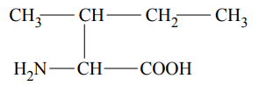 | leucine  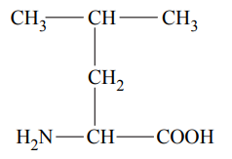

- Draw the structural formula of the ile-leu dipeptide produced by the reaction between isoleucine and leucine at pH 7. 2 marks
0 marks – Structure is incorrect or not given
1 mark – Any correct structure is provided with amino acids in the order ile-leu
2 marks – Correct structural formula (showing all bonds), with amino acids in the order ile-leu, and terminal groups are ionised

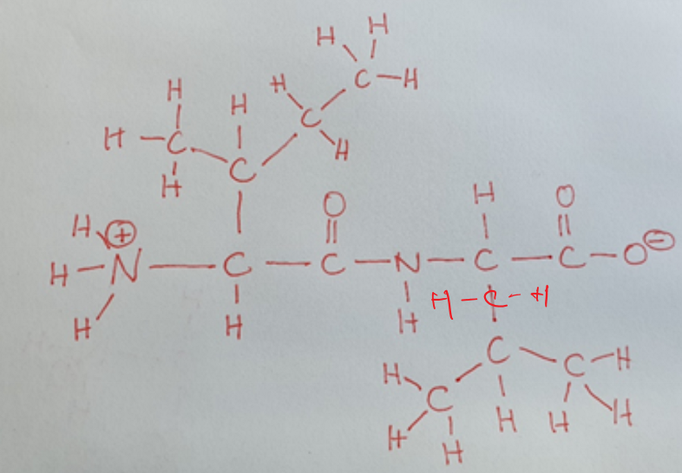

- Glutamic acid, leucine, and threonine are separated using High Performance Liquid Chromatography (HPLC). A non-polar stationary phase and a polar mobile phase are used. Which of the amino acids would have the shortest retention time? Justify your choice. 3 marks

Shortest retention time (circle): glutamic acid leucine threonine (1m)
Justification:
(1m) The most polar amino acid has the least adsorption to the non-polar stationary phase, will more readily desorbed into the polar mobile phase, and will therefore have the shortest retention time.
(1m) Comparing the ‘R’ groups: the R group on leucine is non-polar, glutamic acid has a carboxyl group (-COOH) which makes it the most polar of the 3 amino acids, the -COOH group is more polar than the hydroxyl group (-OH) on threonine.
Note: As all 3 amino acids have the same general structure, the difference will be due to the R group structure.
2 m were awarded where students selected threonine and included the above discussion plus a reference to the relatively small size of the molecule and resulting weaker dispersion forces with the stationary phase.

- Lipoprotein lipase is an enzyme that degrades fat molecules in milk and gives the milk an ‘off (bad)’ flavour. When milk is pasteurised it is heated to 62.8 ºC for 30 minutes. This process inhibits the catalytic function of lipase.

  - Lipoprotein lipase has an optimum temperature of 40ºC. On the axis below, draw a graph to illustrate the expected dependence of activity of the enzyme lipoprotein lipase with increasing temperature. 2 marks
Graph 1: Activity of lipoprotein lipase with increasing temperature
(1m) curve with optimum temperature at 40ºC
(1m) curve shows minimum activity (denaturation) before 62.8ºC
Activity
10 20 30 40 50 60 70
Temperature (ºC)

  - Explain, with reference to structure, why the process of pasteurisation will inhibit the catalytic function of lipase. 2 marks
(1m) If the shape of the active site on lipase is changed in any way, it will not be able to bind to the substrate in order to catalyse the reaction.
(1m) The heating process (pasteurisation) will increase kinetic energy and weaken interactions between side chains (R groups). This will change the secondary, tertiary and quaternary structure, of the enzyme which determine the shape of the active site.

- Saturated fatty acids make up two thirds of the triglycerides found in cow’s milk. A diet high in saturated fats can increase the level of cholesterol (waxy substance) in the blood, which can increase the risk of heart disease. For this reason, many people choose to drink soy milk which is low in saturated fats. Consider the two triglycerides shown below:

Triglyceride A | Triglyceride B
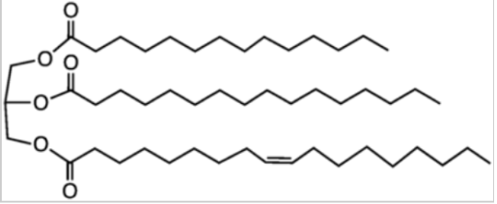 | 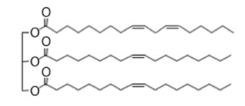

- Which of the triglycerides, A or B, was most likely extracted from cow’s milk? 1 mark
(1m) Triglyceride A

- With reference to structure and bonding, explain which of the triglycerides, A or B, would most likely be a liquid at room temperature. 2 marks
(1m) Structure - Kinks that form, due to the presence of double bonds, will physically separate the chains from each other.
(1m) Bonding – The presence of kinks weakens the overall effect of dispersion forces, and lowers the melting point of the triglyceride.

There are more double bonds present in the fatty acid chains of Tryglyceride B, than Triglyceride A so Triglyceride B is likely to be a liquid at room temperature.
Note: 0 marks awarded for ‘Triglyceride B’ without any explanation

- Refer to the data provided in Table 2 below:

Table 2: Product information on cow’s milk and soy milk
 | Cow’s milk (per 100g) | Soy milk (per 100g)
Protein (total) | 3.6 g | 4.1 g
Fat (total) | 4.3 g | 2.2 g
Carbohydrate (total) | 8.8 g | 7.7 g

Assuming that all energy comes from the fat, protein and carbohydrates, calculate and compare the energy value of cow’s milk and soy milk in kJ g⁻¹. 3 marks
(1m) Cows milk:
$$\frac{\left(3.6 ×17\right)+\left(4.3 ×37\right)+(8.8 ×16)}{100}=3.6 {kJ g}^{-1}$$
(1m) Soy milk: $$\frac{\left(4.1 ×17\right)+\left(2.2 ×37\right)+(7.7 ×16)}{100}=2.7 {kJ g}^{-1}$$
(1m) Cow’s milk has a higher energy value than soy milk

Question 2 (5 marks)
A chemical that contains carbon, C, hydrogen, H and oxygen, O, in the ratio 5:10:2 with a molar mass of
102 g mol⁻¹ is analysed using spectroscopy.
The infra-red (IR) spectrum, ¹H-NMR spectrum and ¹³C-NMR spectrum of the chemical are shown below.

Infra-red (IR) spectrum
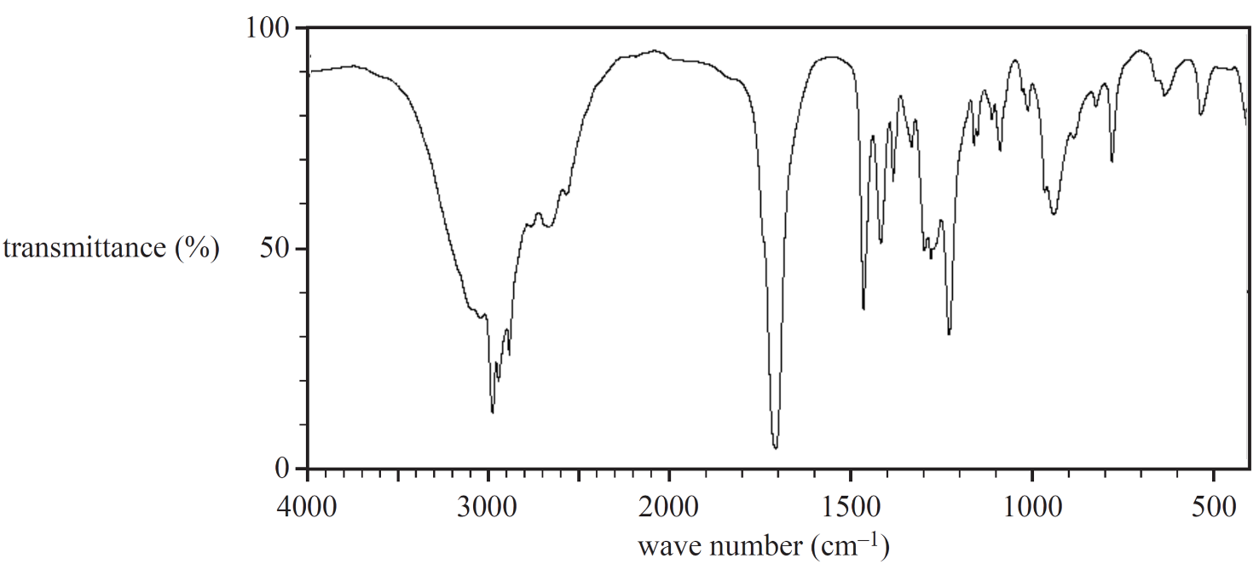
¹H-NMR spectrum
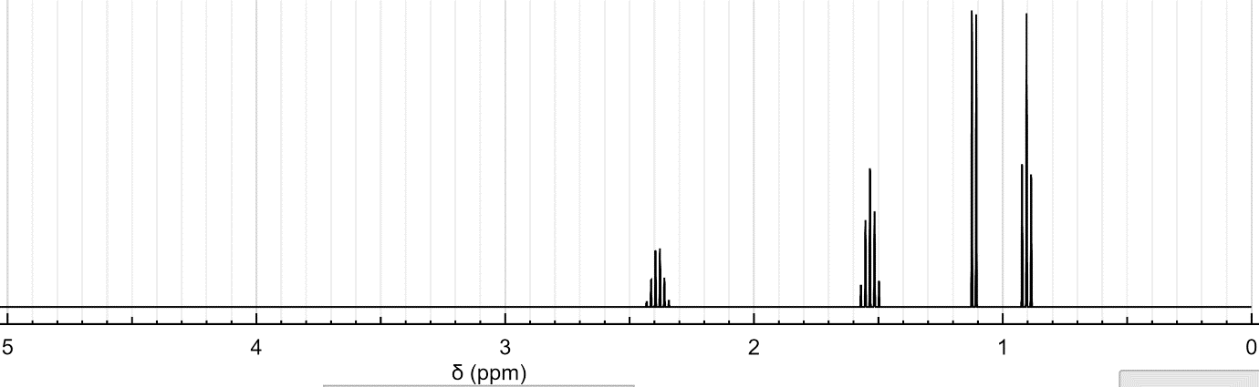
¹³C-NMR spectrum
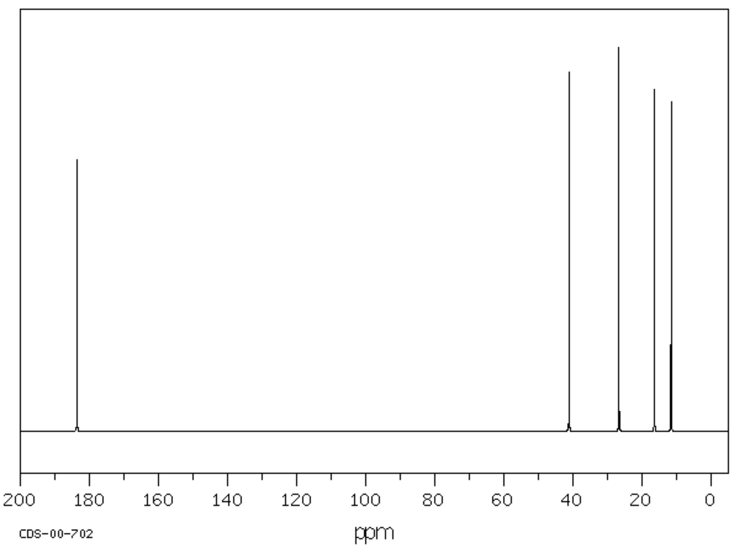

- Identify two distinctive signals from the IR spectrum. 2 marks

Wave number (cm⁻¹) | Most likely bond
~1700 | C=O (acid)
~2800-3300 | OH (acid)
~3000 | C-H
Wave numbers may be read directly from the spectrum or quoted from the Data Book

- Identify the number of carbon environments from the ¹³C-NMR spectrum 1 mark
5

- Draw the skeletal formula for the chemical which is consistent with the infra-red (IR) spectrum, ¹³C-NMR spectrum and ¹H-NMR spectrum. 2 marks
1 mark – any correct structure
2 marks – correct skeletal formula
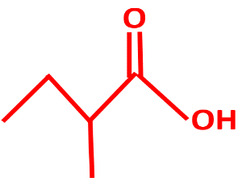
Question 3 (9 marks)
Cellulose and amylose (starch) are two polymers that belong to the class of compounds called carbohydrates.
- The properties of cellulose and amylose (starch) are very different yet they are both polymers glucose.

- Why do cellulose and amylose (starch) have different chemical properties? 1 mark
Cellulose is a polymer of β-glucose while amylose is a polymer of α-glucose

- One of the two polymers, cellulose and amylose (starch), cannot be hydrolysed by the human digestive system. Identify this polymer and explain why humans cannot digest it. 2 marks
(1m) cellulose cannot be hydrolysed by the human digestive system
(1m) humans do not have the enzyme required to hydrolyse cellulose (cellulase)

- Cellulose and amylose (starch) are formed via a process called condensation polymerisation.

- The condensation reaction forms between two functional groups, one on each monomer. Identify these functional groups:
2 marks
Functional group on monomer 1: OH or hydroxyl
Functional group on monomer 2: OH or hydroxyl

- The link that is formed via the condensation reaction is called: 1 mark
Glycosidic link or Ether link

- Plants use starch for storage of energy. Amylose and amylopectin are two forms of starch, which have different solubilities in water. Identify the polymer that is more soluble in water and explain, with reference to structure and bonding, why it is more soluble. 3 marks
(1m) Identify - Amylopectin is more soluble in water
(1m) Structure - Amylose is a linear polymer while amylopectin is branched
(1m) Bonding - Unlike amylose whose molecules pack together tightly, the branching in amylopectin leaves many of its OH groups exposed, therefore allowing for contact, and formation of hydrogen bonds, with water molecules
(students must acknowledge/compare both molecules)

Question 4 (6 marks)
The mass of iron(II) ions, Fe²⁺, in a dissolvable iron tablet was determined by titration with a standardised solution of potassium permanganate, KMnO₄ according to the following method:
Method:
- An iron tablet was dissolved in water and the solution made up to 250 mL in a volumetric flask.
- 25 mL of this solution was added to a second volumetric flask and made up to 250 mL with water.
- A 25.00mL sample of the dilute solution was added to a conical flask along with approximately 20 mL of sulfuric acid.
- A 0.010M standard solution of potassium permanganate was used to titrate the sample.
- The titration was repeated until 3 concordant titres were obtained.
The reaction that took place in this titration involved the oxidation of Fe²⁺ to Fe³⁺ and the reduction of MnO₄⁻ to Mn²⁺. 2 marks
- Write the reduction half equation, and the overall equation for the titration reaction.
Oxidation: ${Fe}^{2+}\left(aq\right)→ {Fe}^{3+}\left(aq\right)+ e^{-}$
(1m) Reduction: MnO₄⁻ (aq) + 8H⁺ (aq) + 5e⁻ → Mn²⁺ (aq) + 4H₂O (l)
(1m) Overall: 5Fe²⁺ (aq) + MnO₄⁻ (aq) + 8H⁺ (aq) → 5Fe³⁺ (aq) + Mn²⁺ (aq) + 4H₂O (l)
States not required

- Why was the iron solution diluted in Step 2? 1 mark
- This minimises waste by ensuring that a reasonable titre volume is delivered
OR
- This ensures that the titre volume will be less than the volume capacity of the burette (the burette will not need to be refilled during the titration).

- Why was an indicator not required for this titration? 1 mark
Permanganate (purple) changes colour once it is reduced to Mn²⁺ (clear). This colour change will be permanent once the endpoint is reached and so an indicator is not required.
(students do not need to identify the colours)

- For this titration, the burette had been washed previously with distilled water only. Explain the likely effect on the calculated mass of Fe²⁺ in the tablet. 2 marks
(1m) The additional water will dilute the KMnO₄ in the burette and therefore the titre volume will be larger than expected
(1m) The larger titre volume will result in higher number of moles and higher mass of Fe²⁺ being calculated

END OF TEST

